**Aimee Shoun**

**Game Essentials**

**Sept 2 2020**

**Research Game**

**Baby Breakout**

**Story**

* Two babies are working together using each others strengths, and they use toy guns and body fluids to defeat the evil nannies and get home to momma.

One baby is short and can get through small spaces and can also be lifted up by the big baby. The big baby can pick and throw the little baby in spots the little baby can’t reach. The player will use his controller to switch between the two babies to complete missions, solve puzzles, and complete the obstacle course that is daycare. The babies will shoot at small enemies who will be the other children in the classroom. They will also defeat boss nannies. They will save their little girl baby friend from time out.

It will be two babies working together to break out of daycare to get home to mommy. They will use there vomit and dirty diapers to fight bad evil nannies . Imaginary friend creatures will appear to help the babies by providing hints and missions.

<https://www.youtube.com/watch?v=QpnY1G3vt_0>

Very Simular to unravel because you will be using two character but you will be switching between the two. Unravel is more like a two player game where this will be strickly a one player game.

There will be objects that the babies will find that will give the babies special abilities for a temporary amount of time. Some will effect health. Some ability coins will effect damage. Some will effect the babies ability to shoot special bullets or lazers. The babies will find guns so they can upgrade their weapon through the game. The guns include sling shots, spit balls, nerf guns, water guns, and giant spit

* **Story**
  + Puzzles
  + Obstacles
  + Shooting AI enemies
  + Like skylanders
  + Save another baby from time out.
* **Game Mechanics** 
  + Jumping
  + Looting
  + Flying
  + Grabbing
  + Walking
  + Shooting
  + Digging
  + Looking
  + Sprinting
  + Croutching
  + Crawling
  + Falling
  + Swimming
  + Punching
  + Breaking
  + Sliding
  + Throwing
* **Aesthetic**
  + Light fun colors
  + Colorful
  + Simple textures for the tables, floor, grass, walls.
  + Fun easy going energy
  + Silly, funny, jokes
  + Gross humor
  + Steady even pace
  + Made for kids or young adults
  + Daycare
  + Playground
  + Mommys home
  + Neighborhood
  + Obstacles
  + Bushes
  + Streets
  + Tables
  + Toys
  + Jungle gym
  + Nanny characters
  + Other babies characters
  + Cheer music

I like this screen grab.

* I want to use simple pixlated graphics of hearts for the health.
* I also want to use building block toys to create obstacles and also direct the player where I want them to go.
* I want my small enemies ( the other baby classmates) have health bar above them.
* I want there to be a tracking of were you want to aim the diaper that the babies will be throwing like grenades.

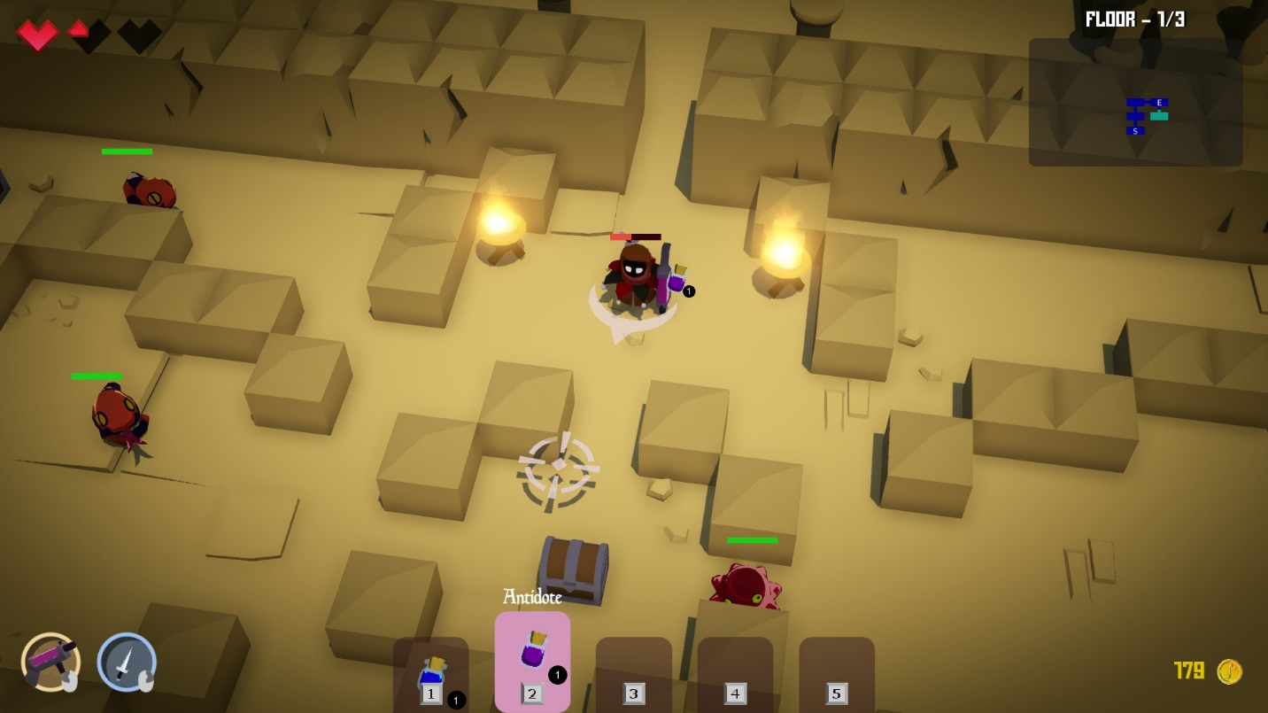

* **When the babies are outside. I want to use bushes to direct the player were I want the player to go.**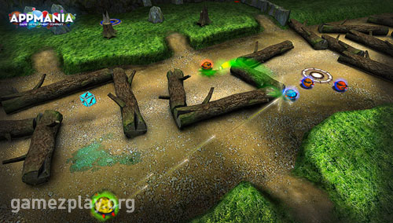
* **This pallete is to help when designing the front end.I want t okeep the colors simple and light and playful.** 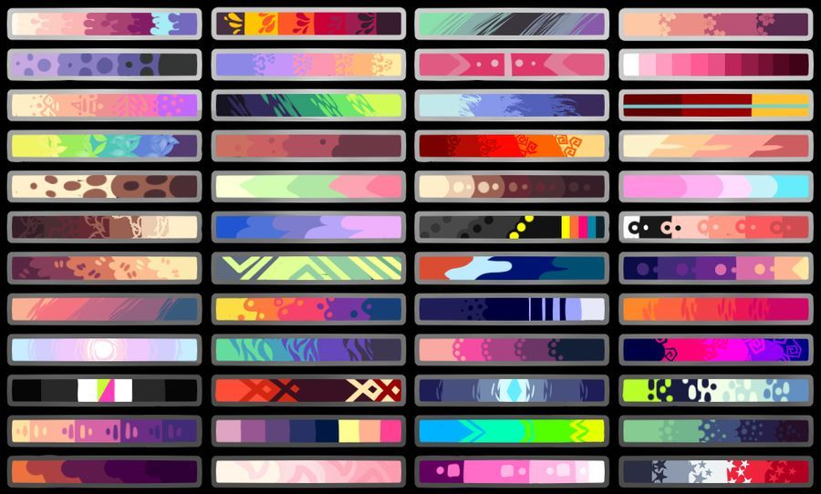
* **I want the asthetic to look and the characters to look like this. ver y cute and colorful like this game.** 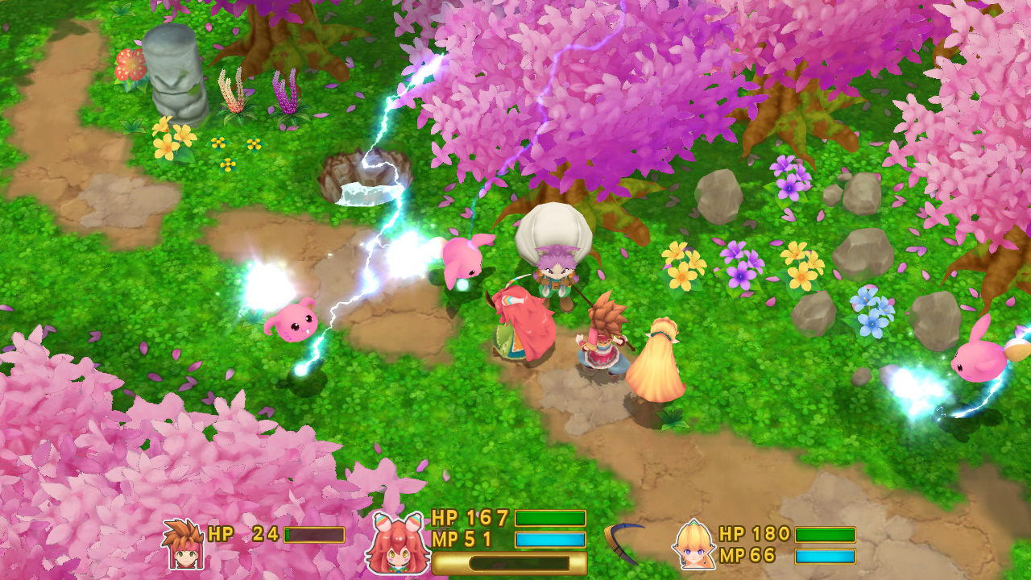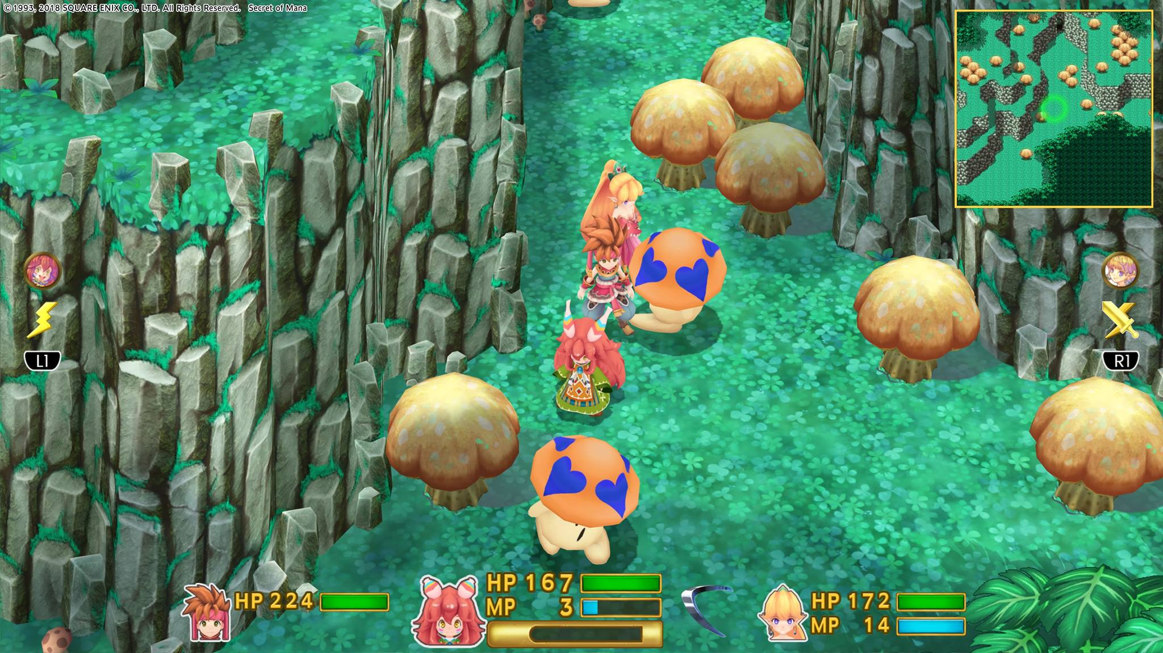
* **I want to use fun particles like this when the baby picks something up or defeats an enemy**
* **My biggest inspiration is skylanders**
* **the platform will be very simular to skylanders. It will be a guided obstacle puzzle game with shootem up abilities.**
* **skylander**
* [**https://www.youtube.com/watch?v=HJLUx0qLpXU&t=997s**](https://www.youtube.com/watch?v=HJLUx0qLpXU&t=997s)
* 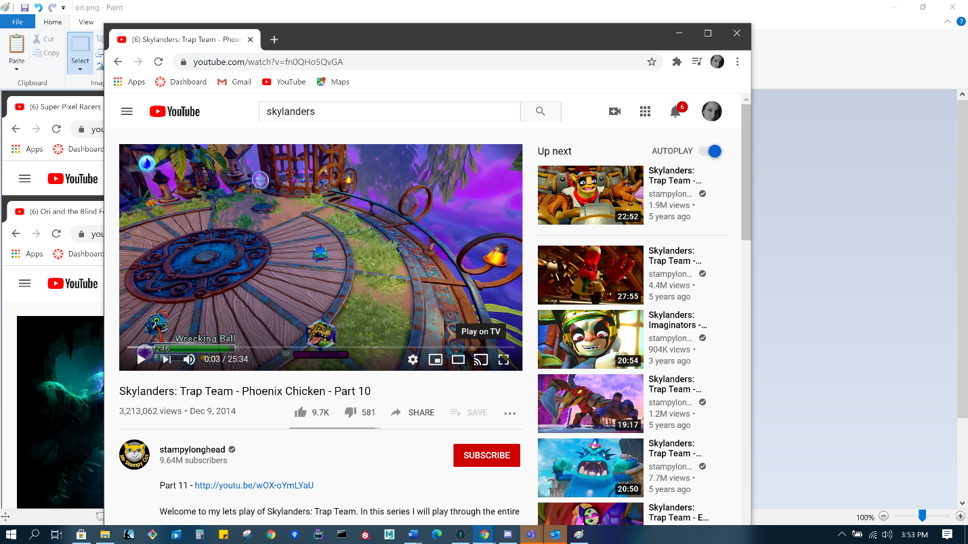
* **The way the camera will follow the character is like in zelda links awakening**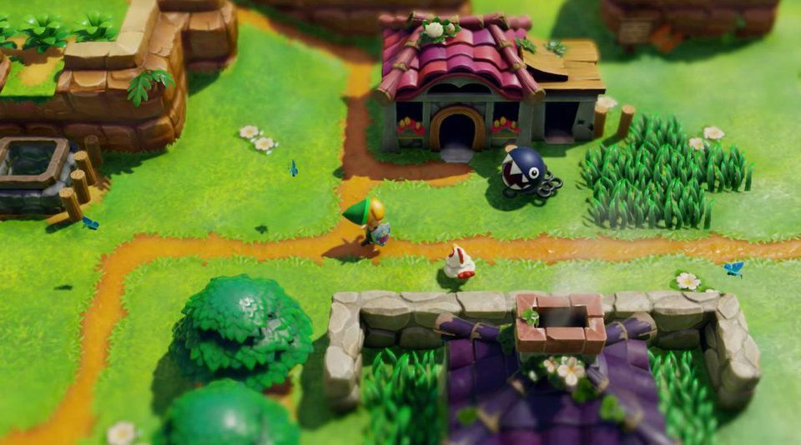
* bubbles as well as dirty diapers.